SOLAR PANEL SURFACE MONITORING
Detect surface irregularities in panel images using OpenCV edge and spot detection
Student Name: B. PRITHIVRAJ
Batch No: 25
Student Id: 2362848
Course: Drone Technologies and its Transformative Applications
CIA 3 – Project Activity
GitHub Link: https://github.com/prithiv19894476-ops/solar-panel-surface-monitoring

- Aim:
The aim of this project is to detect dust, cracks, and other surface defects on solar panels using image processing techniques. The system uses Python and OpenCV to analyse solar panel images, detect irregularities, calculate the defect area percentage, and classify the severity level.

Problem Statement:
Renewable energy firms want to check cleanliness and surface defects on solar panels.
A. Detect surface irregularities in panel images using OpenCV edge and spot detection.
B. Quantify defect area percentage and classify severity.

3.Objectives:
The objectives of this project are:
- To capture or load solar panel images.
- To detect surface irregularities using image processing.
- To identify cracks and dust spots using edge detection and thresholding.
- To calculate the percentage of defective area.
- To classify the severity of the defect as Low, Medium, or High.

4.Tools and Technologies Used:
Tool / Technology | Purpose
Python | Programming language used for the project
OpenCV | Image processing library
NumPy | Used for numerical calculations
Computer System | To run the program
Solar Panel Image | Input image for defect detection

5.Methodology:
The following steps are used in the project:
- Image Input
The solar panel image is loaded into the program.
- Grayscale Conversion
The image is converted into grayscale to simplify the processing.
- Noise Reduction
Gaussian blur is applied to remove noise from the image.
- Edge Detection
Edge detection is performed to identify cracks or scratches on the panel.
- Spot Detection
Thresholding is applied to detect dust or stain spots.
- Defect Area Calculation
The program calculates the number of defective pixels and determines the defect percentage.
- Severity Classification
Based on the defect percentage, the defect severity is classified as Low, Medium, or High.

6.Python Program:
import cv2
import numpy as np

image = cv2.imread("solar_panel.jpg")

gray = cv2.cvtColor(image, cv2.COLOR_BGR2GRAY)

blur = cv2.GaussianBlur(gray, (5,5), 0)

edges = cv2.Canny(blur, 50, 150)

_, thresh = cv2.threshold(gray, 200, 255, cv2.THRESH_BINARY_INV)

defect_pixels = np.sum(thresh == 255)
total_pixels = thresh.size
defect_percentage = (defect_pixels / total_pixels) * 100

if defect_percentage < 5:
severity = "Low"
elif defect_percentage < 15:
severity = "Medium"
else:
severity = "High"

print("Defect Percentage:", defect_percentage)
print("Severity:", severity)

cv2.imshow("Original Image", image)
cv2.imshow("Edge Detection", edges)
cv2.imshow("Defect Detection", thresh)

cv2.waitKey(0)
cv2.destroyAllWindows()
7.Results:
The developed system successfully detects surface defects on solar panel images using image processing techniques. The input image of the solar panel is processed using OpenCV, where the image is converted into grayscale and filtered to remove noise.

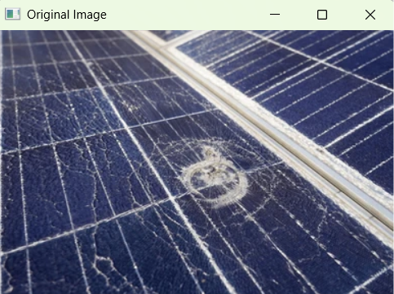
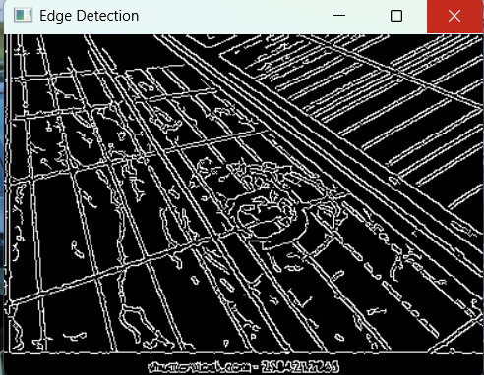

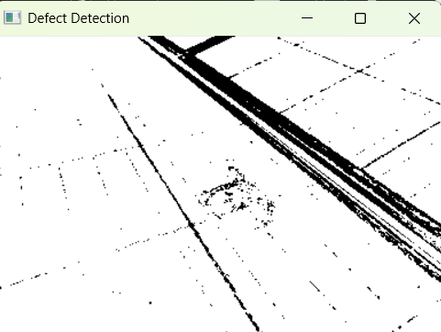

8.Advantages:
- Reduces manual inspection effort.
- Detects small defects accurately.
- Improves maintenance of solar panels.
- Helps increase solar panel efficiency.

9.Applications:
- Solar power plants
- Renewable energy companies
- Solar panel maintenance systems
- Automated inspection systems

10.Conclusion:
The Solar Panel Surface Monitoring system uses image processing techniques to detect defects on solar panels. By using OpenCV and Python, the system identifies cracks, dust, and irregularities on the panel surface. It calculates the defect area percentage and classifies the severity level. This automated approach can help renewable energy companies maintain solar panels more efficiently and improve power generation performance.

11.Future Scope:
The Solar Panel Surface Monitoring system can be further improved and expanded in several ways. In the future, advanced technologies can be integrated to make the system more accurate and efficient.
- The system can be connected with drones to capture solar panel images automatically in large solar farms.
- Machine learning and deep learning techniques can be used to improve the accuracy of defect detection.
- Real-time monitoring systems can be developed to continuously check solar panels.
- The system can be integrated with IoT devices to send alerts when defects are detected.
- A mobile or web application can be developed to monitor solar panel conditions remotely.
These improvements will help renewable energy companies maintain solar panels more effectively and improve power generation efficiency.

